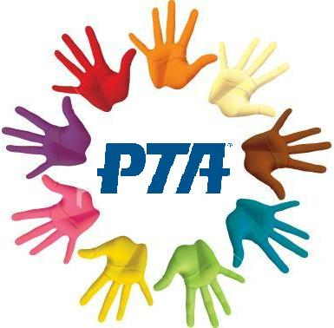

Invites all Yelvertoft School Children To Our Cinema Night Of:

**The Super Mario Bros Movie**



**Certificate PG**

* **Where:** **School Hall**
* **When:** **Tuesday 7th May 2024 Whole School Finish Time 5pm**
* **Cost:** **£3.50 – small snack & drink will be provided**

*If you would like your child to come along, please complete the consent slip below with the correct payment and return to school by* ***Friday 3rd May 2024.* Bank Transfer: Yelvertoft School Association Account No: 47639636 Sort Code: 60-13-30**

**reference: Your Childs Name or Cash.**

**I am happy for** ……………………………................ **in class** ……

to attend Children’s Cinema Night – **The Super Mario Bros Movie** – on Tuesday 7th May 2024 for the whole school. I understand that this is a PG certificate and give consent for my child to watch this movie.

**Delete as necessary**

My child does/does not have any food allergies or special diet.

Please choose one drink Orange Juice/ Apple Juice

……………………………………………………………………………

I enclose: **£**………

Parent/carer signature………………………………………………

***Children’s Cinema Night***